The American Association of Teachers of Spanish and Portuguese

Sociedad Honoraria Hispánica

**Certificado de Excelencia**

otorgado a



Insert Student Name Here Capítulo de Insert Chapter Name Here

Expedido el día de de 2025

Asesor(a) del capítulo Presidenta

Director(a) de la escuela

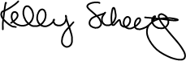

Directora Nacional